# Build an EMA-based Signal Strategy

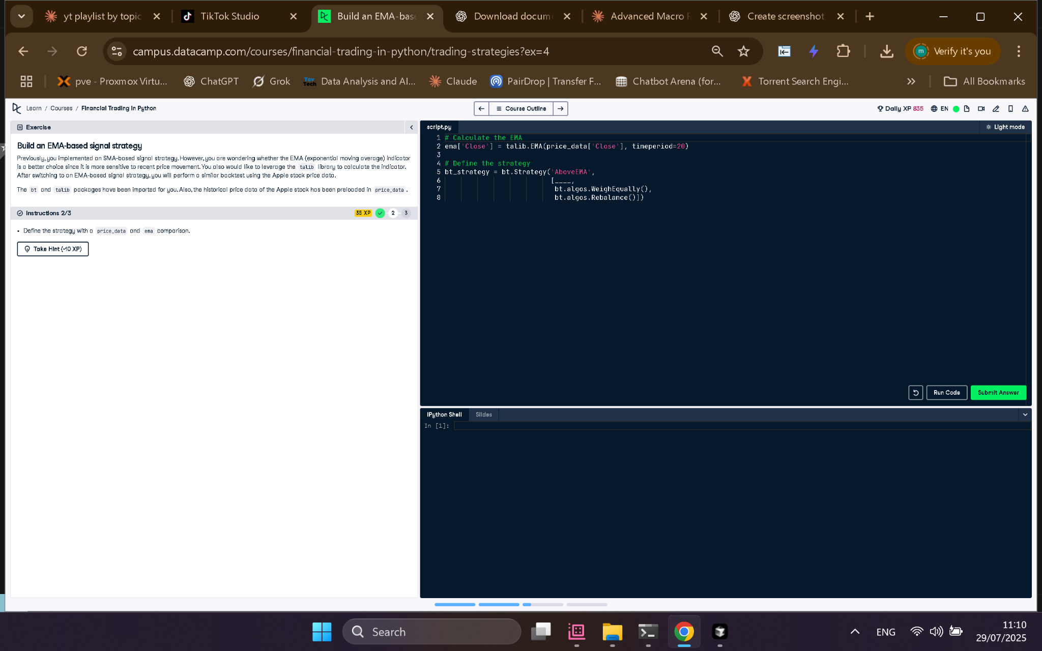

## Full Python Code

# Calculate the EMA  
ema['Close'] = talib.EMA(price_data['Close'], timeperiod=20)  
  
# Define the strategy  
bt_strategy = bt.Strategy('AboveEMA',  
 [bt.algos.SelectWhere(price_data > ema),  
 bt.algos.WeighEqually(),  
 bt.algos.Rebalance()])

## Explanation in Simple Words

This code builds a trading strategy using the EMA. First, it calculates the 20-day EMA for the stock's closing price. Then, it defines a strategy that selects stocks where the price is above the EMA, assigns equal weights to them, and rebalances the portfolio. This helps identify upward momentum.